Barnburgh Primary Academy
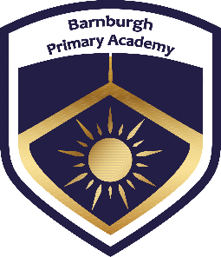

Phonics and Early Reading Guide for Parents and Carers

At Barnburgh Primary Academy, your child is learning to read with Read Write Inc. Phonics, a very popular and successful early reading programme.

Your child will learn to read in a very simple way. They will learn to:
- Read letters by their ‘sounds’
- Blend these sounds into words
- Read the words in a story

What is phonics?

Phonics is a way of teaching children to read quickly and skilfully.

They are taught how to:
- recognise the sounds that each individual letter makes;
- identify the sounds that different combinations of letters make - such as ‘sh’ or ‘oo’; and
- blend these sounds together from left to right to make a word.

Children can then use this knowledge to ‘de-code’ new words that they hear or see. This is the first important step in learning to read.

Key Vocabulary
Blending
Blending involves merging the sounds in a word together in order to pronounce it. This is important for reading. For example, j-a-m blended together reads the word jam.

Consonant
The letters of the alphabet (apart from the vowels a, e, i, o and u).

CVC words
An abbreviation for consonant-vowel-consonant. This is a simple way of indicating the order of the graphemes in words. For example, it (VC), cat (CVC), bench (CVCC).

Digraph
A grapheme made up of two letters that makes one sound (sh in fish).

Grapheme
A grapheme is simply a way of writing down a phoneme. A grapheme can be one letter (s), two letters (ir), three letters (igh) or four letters in length (ough).

Grapheme-phoneme correspondences (GPCs)
Knowing your GPCs means being able to hear a phoneme and knowing what grapheme to use to represent it. This is helpful for spelling. Conversely, it also means seeing a grapheme and knowing the phoneme that relates to it, which is important for reading.

Phoneme
The smallest unit of sound in a word. There are around 44 phonemes in English and they are represented by graphemes in writing. Phonemes are usually shown as symbols between two forward slashes. For example, /b/ or /ch/.

Segmenting
Segmenting involves breaking up a word that you hear into its sounds. This helps with spelling because if you know what graphemes represent the sounds in the word, you can write it! For example, the word jam is segmented into the sounds j-a-m.

Split digraph
A digraph that is split between a consonant (a-e in make). A split digraph usually changes the sound of the first vowel. For example, compare the pronunciation between hug and huge.

Red words
Words that are commonly used in English, but they have complex spelling patterns which make them difficult to read and write. For example: said, of and was.

Trigraph
A grapheme made up of three letters that makes one sound (igh in high).

Vowel
The letters a, e, i, o and u.

Set 1 Sounds - Reading
To begin with, your child will learn to read Set 1 Speed Sounds. These are all sounds that are written with one letter or two letters. It is important that children learn the sounds and not the letter name. The following sounds are Set 1 sounds and this is the order in which they are taught:
m a s d t i n p g o c k u b f e l h r j v y w z x

Children will also learn 7 sounds in Set 1 that have two letters. These are called ‘special friends’ and we explain that these two letters together make one sound. The specific term for these sounds is a digraph.

nk ng sh ch th qu ck

Children will learn how to orally segment and blend words. This means they will be able to hear the individual sounds (segmenting) and then hear the sounds together (blending). For example, if an adult says j-a-m the child will hear the individual sounds and then be able to hear that the word is ‘jam’. We use the character Fred the Frog to help us segment and blend. We call this Fred Talk.

Once children are confident at doing this orally, they will then move onto reading the sounds in words (segmenting) in order to read the word together (blending). To begin with, this will be short words such as cat, map, big, six before longer words containing ‘special friends’ are introduced such as chip, shop, bath, sing.

Children will move through the following reading book levels whilst learning set 1 sounds – sound blending books, ditty sheets, red, green and purple books.
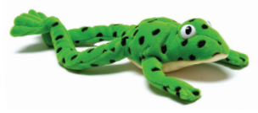
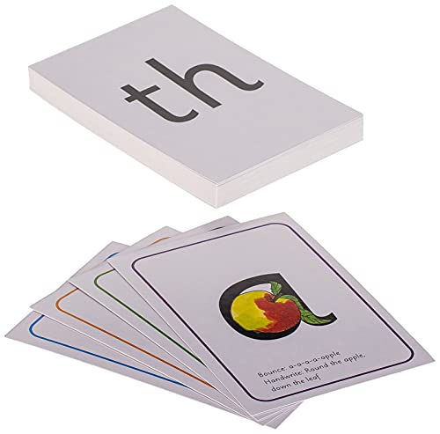

Set 1 Sounds – Writing
As part of the Read, Write, Inc. phonics scheme, children will learn how to form letters correctly in order to write the sounds that they hear in words. Each sound that children learn has a writing rhyme. Children should be encouraged to think about the rhyme when writing letters.

Here are some examples of the writing rhymes:
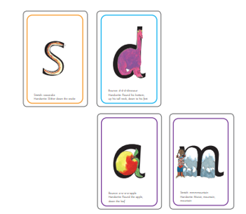
m – Maisie, mountain, mountain

a – around the apple, down the leave

d – around the dinosaurs bottom, up his tall neck and down to his feet

s – slither down the snake

A full list of the handwriting rhymes is available at the back of this booklet.

When writing independently, children may hear and write the initial sounds and then the final sounds that they hear in a word.

For example, if a child was writing the word ‘snake’ they may write ‘sk’ as they’ve heard the initial and final sounds.

It is also common in early writing for children to confuse the ‘tr’ sound for ‘ch’ such as when writing ‘trap’. Most writing at this early stage will be phonetically plausible – they write what they can hear in the word.

Set 2 Sounds – Reading
Once children are confidently and fluently reading set 1 sounds within words, they will begin to learn set 2 sounds. All the sounds in set 2 are made up of 2 or 3 letters. Children will recognise them as ‘special friends’ and should look for them within words they are reading. The following sounds are set 2 sounds and this is the order that they are taught:

ay ee igh ow (as in snow) oo (as in moon) oo (as in book) ar or air ir ou oy

When reading words, children are always encouraged to follow this routine:
- Are there any special friends? (If there are, say them)
- Fred talk the word
- Blend the word to read it

So for the word ‘sleep’ it would be:
- Special friends? ee
- s-l-ee-p
- sleep

When children are reading set 2 sounds confidently, they will read pink, orange and yellow storybooks. During each lesson, children will have the opportunity to read words containing all the sounds that have learned so far in set 1, 2 and 3. They will also read ‘alien’ words which are words that can be segmented and blended but they are made up words. This allows children to practise their decoding skills. The children will also read a selection of words that they are able to read without decoding.
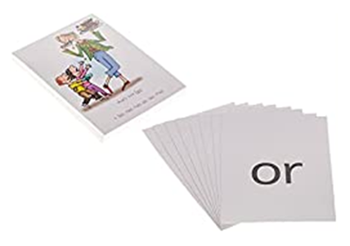

Set 2 Sounds – Writing
When children are learning to write, we encourage them to Fred talk the word first to allow them to consider the sounds that they can hear within the word before writing it.

For example, when writing the word ‘sharp’ children are encouraged to hear the individual sounds – sh-ar-p before then ‘pinching’ these sounds onto the fingers of their non-writing hand. Children hold up their hand with the correct number of fingers to show the sounds in the word. For ‘sharp’ they would hold up 3 fingers then pinch the sounds on. They then write the sounds they hear, referring back to sounding out the word as often as they need.

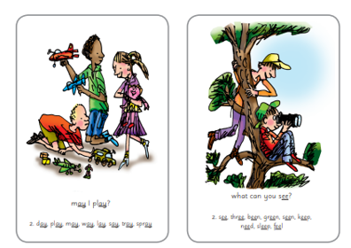
Each sound has a phrase and a picture to help the children remember it.
Here are some examples:

ee – what do you see?

ay – may I play?

igh – fly high

A full list of set 2 and 3 sounds is available at the back of this booklet.

Set 3 Sounds – Reading
Once children are confidently and fluently reading set 2 sounds within words, they will begin to learn set 3 sounds. All the sounds in set 3 are made up of 2, 3 or 4 letters. Children will recognise them as ‘special friends’ and should look for them within words they are reading. Some sounds contain a split digraph, this is where 2 letters make one sound but there is another sound sat in the middle that comes at the end, for example, the word ‘cake’. The following sounds are set 3 sounds and this is the order that they are taught:

ea oi a-e i-e o-e u-e e-e aw are (as in share) ur er ow (as in cow) ai oa ew ire ear ure au kn ie

ue ph wh tion tious cious

Once children are reading set 3 sounds, they will read yellow, blue or grey storybooks. At this stage, it is important that children focus on developing their fluency when reading – this simply means reading without segmenting and blending each word.

During each lesson, children will have the opportunity to read words containing all the sounds that have learned so far in set 1, 2 and 3. They will also read ‘alien’ words which are words that can be segmented and blended but they are made up words. This allows children to practise their decoding skills. The children will also read a selection of words that they are able to read without decoding.

The writing element of Set 3 is the same process as for set 2.

Green, Red, White and Alien Words

Green words – These are words that can be decoded – children should look for any special friends, Fred talk then read the word.

Alien words - These are nonsense words that can be decoded – children should look for any special friends, Fred talk then read the word.

Red words – These words are taught through the storybooks. They are words that cannot be decoded or do not fit a specific reading rule.

White words - These are words that children can decode in their heads (Fred in your head) – children should look for any special friends, Fred talk in their head then read the word. These are words that children are familiar with.

Lesson Structure for Phonics

Each phonics lesson follows the same structure each day and this allows the children to develop a strong knowledge of the sounds they have learned and how to read and write them.

A brief overview of how the lessons are structured is as follows:

- Introdution of the sound
- Speed sound recap of the sounds learned so far
- Writing the sound
- Reading green words (or oral segmenting and blending for children who are not yet reading)
- Reading alien words
- Writing green words
- Storybook

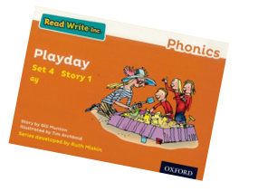
Storybooks and Reading Levels
Each half term, children are assessed by a familiar adult to understand their current reading level. This indicates the coloured level that children will bring home to read to an adult. This is also the colour band storybook that they will read as part of their phonics lesson. Children practise reading everyday in school with a partner and an adult will listen to them read during each phonics lesson. It is recommended that children read at least 3 times a week to an adult at home. The book the children bring home should be one that they are able to read with ease without needing an adult to prompt.

Reading a story is also more than just reading the words. We develop children’s ability to talk about what is happening in the story, what might happen next, who the characters are and how they are feeling.

E-Library

The E-Library is accessible via the Oxford Owl website and you will be able to log in from home to allow your child to access a range of books that are suitable for their current reading level. All children will receive their own log in. These books are an online version of the books that children read in their phonics lessons and they can revisit previous books they have read and enjoyed.

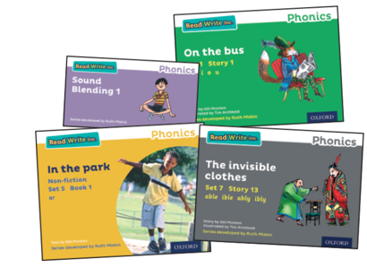

Phonics Screening Check

The phonics screening check will be taken individually by all children in Year 1, in England, from June 2012. It is designed to give teachers and parents, information on how your son/daughter is progressing in phonics.

What is the phonic screening check?
There will be two sections in this 40-word check and it will assess phonics skills and knowledge learnt through Reception and Year 1.

What will it check?

It will check that your son/daughter can:
• Sound out and blend sounds in order to read simple words.
• Read phonically decodable one-syllable and two-syllable words, e.g. cat, sand, windmill.
• Read a selection of nonsense words which are referred to as pseudo words.

What are nonsense or pseudo words and why are they included?

These are words that are phonically decodable but are not actual words with an associated meaning e.g. brip, snorb. Pseudo words are included in the check specifically to assess whether your son/daughter can decode a word using phonics skills and not their memory. The pseudo words will be shown to your son/daughter with a picture of a monster and they will be asked to tell their teacher what sort of monster it is by reading the word. This not only makes the check a bit more fun, but provides the children with a context for the nonsense word which is independent from any existing vocabulary they may have. Crucially, it does not provide any clues, so your son/daughter just has to be able to decode it.

Is there a pass mark?
The check is not about passing or failing but checking appropriate progress is being made. Children progress at different speeds so not reaching the threshold score does not necessarily mean there is a serious problem. Your son/daughter will re-sit the check the following summer term. The pass mark has been at 32 for the last few years but this information is not released until after the checks are completed.

What happens to the results?
The school will report your son’s/daughter’s results to you by the end of the summer term as well as to the local authority. If you have any concerns, do talk to your teacher about this in a parents’ meeting or after school.
Apps | Websites | Other
Teach Your Monster to Read  Hairy Phonics  Meet the Alphablocks  Read with Phonics  Some of these apps cost but are occasionally free to download so keep an eye out! | https://www.topmarks.co.uk/english-games/5-7-years/letters-and-sounds  https://www.phonicsplay.co.uk/freeIndex.htm  http://www.familylearning.org.uk/phonics_games.html  http://ictgames.com/forestPhonics/fullV_public/index.html  https://www.ictgames.com/mobilePage/literacy.html  https://www.bbc.co.uk/bitesize/topics/zcqqtfr  https://www.phonicsbloom.com/  https://www.oxfordowl.co.uk/for-home/advice-for-parents/fun-ideas-learning-at-home/fun-ideas-ages-5-6/  Please note that these apps and websites do not necessarily match the Read, Write, Inc. phonics scheme but are still extremely useful! | Search ‘Phonics Family’ on Facebook for lots of amazing and creative ideas for having fun with phonics at home!  Sign up for a free Twinkl account and search ‘phonics’ for resources to download and print for use at home.  ‘Five Minute Mum’ also has fantastic phonics ideas. Search on Facebook or, alternatively, the books are available to buy on Amazon. These also include ideas for other areas of early learning.  Read, Write, Inc. guide for parents:  https://home.oxfordowl.co.uk/reading/reading-schemes-oxford-levels/read-write-inc-phonics-guide/



